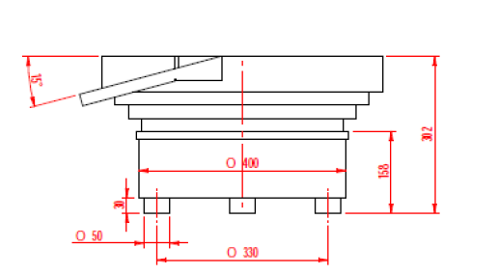
- FRONT VIEW

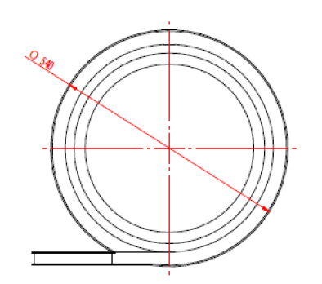
- TOP VIEW
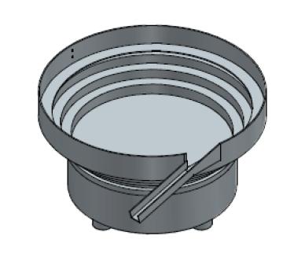
( c) BASIC PRODUCT VIEW

SCOPE OF WORK:
1) Purpose of Machine in Brief –
a) For Metallic Strips:
It consists of:
- NIHVA Bowl Orientor and feeder system –Clockwise Direction.
- Magazine (Guide) Unit.
- Gravity Chute – Guide Length 300mm.
- Main Stand – Led Screw Type.
- High/Low Level Sensor with Mounting Stand.
- Controller.
- Quantity – 1 Set.
2) NIHVA Scope of Supply:
- NIHVA system will be user friendly.
- NIHVA will provide CE Inspection Certificate for all the Part 100 % orientation before final dispatch.
3) Operation Sequence
- The parts will be oriented by respective feeder system with a required orientation as per the drawings.
- The oriented part will be in a resting position at front side of the existing chute & from their will be feed linearly through gravity chute for further sub assembly operation to your SPM machine.
- The part will be released at a time, on to the final position.
- Soon as the assembly station is indexed, the next lot will be ready for the action.
- Speed: As per your requirement i.e. 45 pcs per track per min.
- Electrical Power: - Single Phase, 220 Volts, 3 Ampere

4) Other Terms & Conditions:
Warranty on the system – 2 Years & on vibrator drive unit – 5 Years as we are importing fibre plates from Germany which we are using in the DRIVE UNIT

